**LADS-License-Authorization-and-Driver's-Saftey**

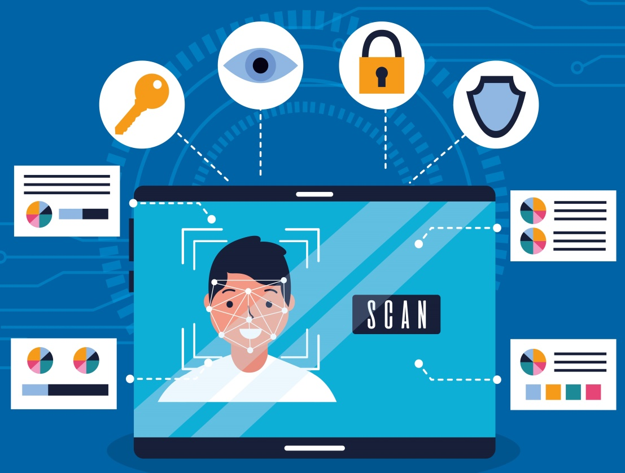

This is a software which helps in prevention of accidents due to unauthorized driving and drowsiness, and helps so many transport services to stop unauthorized driving.

**The Working process FLOW CHART**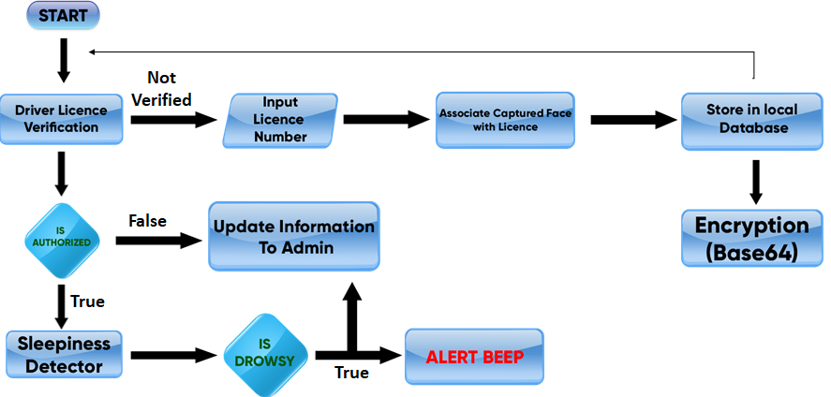

1. **Driver Licence Verification**

When the person enters the vehicle the facial detection starts, and starts recognizing the person, the recognized face will be checked through database of admin and confirms if the person is authorized or not

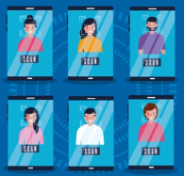

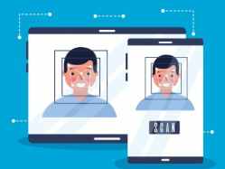

If the person is not authorized he/she will be given option to register, the person have to enter government authorized licence number and within few steps he/she will be able to register and the detection starts again ,if the person doesn’t have authorized licence ,the person recognized data will be sent to admin through cloud.All this data will be encrypted data which is encrypted using Base 64 encryption.

And if the person face is not recognized due to any problem, we provided a alternative method for that which is barcode, the person who is not recognized will get a option to send a QR-code to his registered email. Now he can show that QR-code to camera instead of his face.

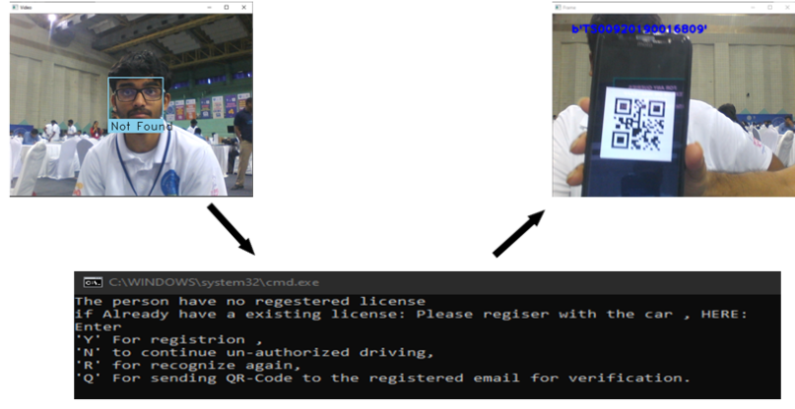

And if the person is un authorized and there is an emergency for him to drive, he can choose the option to continue un-authorized driving for that time, and as usual the admin gets this data.

* How User see the data.(Encrypted)

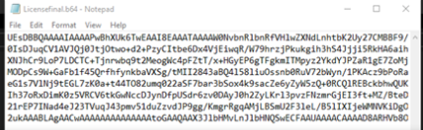

* How Admins Access it.(Decrypted)

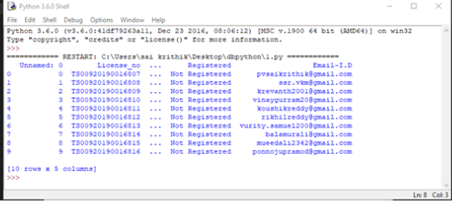

2)Sleepiness Detector

After the first step sleepiness detection will start, in the background drowsiness detection runs with the help eye lashes landmarks and constantly recognizes if the the person is drowsy or not ,if the person is drowsy an alarm turns on ,which helps him to stay alert and a message will be sent admin at the end of the day using cloud will be encrypted as well, so that the admin will be able to take actions about it

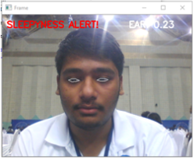

**Tools Used:**

1. **Python for programming**
2. **OpenCV,Dlib,FaceRecognition,numpy**
3. **TransferLearning is used for Modeling**

# Who Benefits?:

Commercial: All transport service providers like Uber ,Ola etc

Personally: Everyone specially who works at night this will be very helpful.